Effects of pre-carbonization on porosity development of activated carbons from rice straw



Carbon
Volume 39, Issue 4, April 2001, Pages 559-567
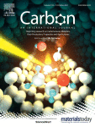

Effects of pre-carbonization on porosity development of activated carbons from rice straw
Author links open overlay panelChang HunYunªYun HeumParkªChong RaePark^{b}

